THE ICENYÄ NATIONAL EXAMINATIONS COUNCIL
Kenya Certificate of Secondary Education
311/1 Paper 1


HISTORY AND GOVERNMENT
Mar. 2022 — 2h hours

Name Index Number
Candidate's SignatureDate

Instructions to candidates
Write your name and index number in the spaces provided above. (b) Sign and write the date of examination in the spaces provided above.
- This paper consists of three sections; A, B and C.
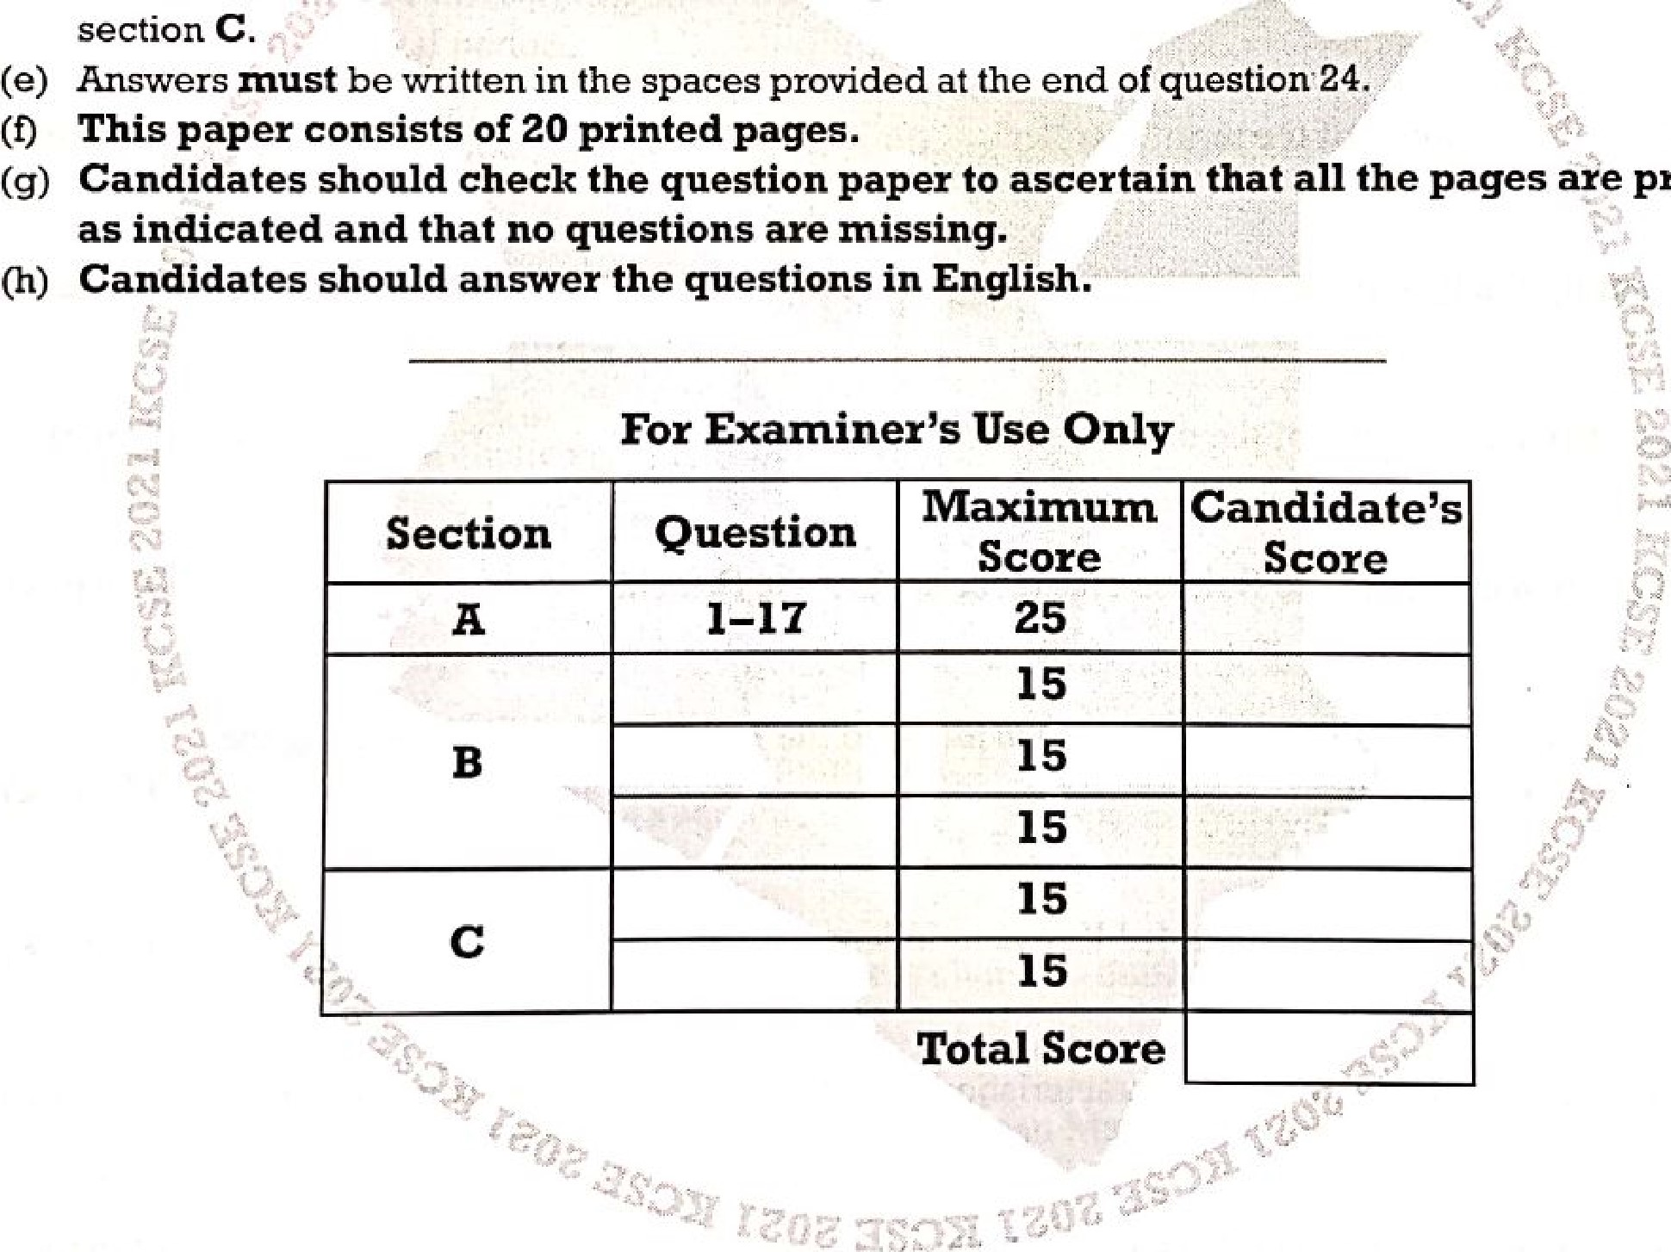
- Answer all the questions in section A, three questions from section B and two questions from section C.
printed
(O
(g)

0 2021 The Kenya National Examinations Council 
915039 Turn over
2
A (25 all t/f(i ////s secl/on /// space prov/(/ed //lteslion 24,
t. Identity linguistic ill Kenyn, (2 mark%)
 State two ways in which the Agikuyu interacted with the Akamba during the pre-colonial period. (2 marks)
Give the tunin econoltlic activity oc the Plain Niloles during the pre-colonial period. (l mark)
4. Ilighlight two factors which led 10 the increase in demand for slaves along the East African
Coast during the 19th Century.  - Name the document which contains the Bill of Rights for Kenyan citizens.  - Give the meaning of the term 'conflict'.  - Identify the type ofconstitution that is used in Kenya.  8, Identify two colours ofthe national flag in Kenya.  9. State two causes of the Bukusu resistance against the British. | (2 marks)  (l mark)  (1 mark)  (l mark)  (2 marks)  (2 marks)
10. Identify the Cushitic community which attacked the Bantu at Shungwaya during the
pre-colonial period.  - Name the political party that led Kenya to independence.  - State one common political characteristic ofthe National Philosophies in Kenya.  - Give two types of elections held in Kenya. | (l mark)  (1 mark)  (l mark)  (2 marks)
Kenya Certificate ofSecondary Education, 2021
915039 311/1
3
(2 marks) 14. Highlight two branches of the National Government of Kenya.
(l mark) 15. Give one reason for the adoption ofAfrican Socialism in Kenya.
- Identify the commission that recommended cost-sharing in education sector in Kenya. (l mark)
- State two ways in which the National Government of Kenya spends its recurrent expenditure.
(2 marks)
SECTION B (45 marks)
Answer any three questions from this section in the space provided after question 24.
- (a) State five causes of migration of the Highland Nilotes into Kenya during the pre-colonial period. (5 marks)
  - Describe the social organisation of the Borana in the 19th Century. (10 marks)
- (a) Identify five categories of special groups of people whose rights are enshrined in the
Constitution of Kenya. (5 marks)
  - Explain five challenges faced by African political organisations in Kenya up to 1939.
(I O marks)
- (a) Highlight five features of the independence Constitution of Kenya. (5 marks)
  - Discuss five factors which led to the collapse of the Imperial British East African
Company (IBEAC) in 1894. (10 marks)
- (a) State five characteristics of independent churches during the colonial period in Kenya.
(5 marks)
  - Explain five roles played by women in the Mau Mau liberation movement in Kenya.
(10 marks)
Kenya Certificate ofSecondary Education, 2021
915039 Turn over

SECTION C (30 marks)
Answer any two questions from this section in the space provided after question 24.
- (a) Give the three members of the Executive Committees of County Governments in
Kenya. (3 marks)
  - Discuss six functions of a County Governor in Kenya- (12 marks)
- (a) State the Composition of the Cabinet in Kenya. (3 marks)
  - Explain six functions ofthe National Assembly in Kenya. (12 marks)
- (a) Name the three branches of the Kenya Defence Forces. (3 mz&s)
  - Discuss six functions of the Kenya Police Service. (12 nuns)

Kenya Certificate ofSecondary Education, 2021 915039

Kenya Certificate ofSecondary Education, 2021
915039 Turn over

