THE KENYÄ NÄTIONÄL EXAMINATIONS COUNCIL
Kenya Certificate of Secondary Education
101/2 ENGLISH Paper 2
(Comprehension,
Literary Appreciation and Grammar)
Mar. 2022 - 2 ¹/2 hours
Name
Index
Number
Candidate's Signature Date

Instructions to candidates
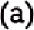Write your name and index number in the spaces provided above. (b) Sign and write the date of examination in the spaces provided above.
- Answer all the questions in this question paper.
- All your answers must be written in the spaces provided in this question paper. This paper consists of 12 printed pages.
(f) Candidates should check the question paper to ascertain that all the pages are
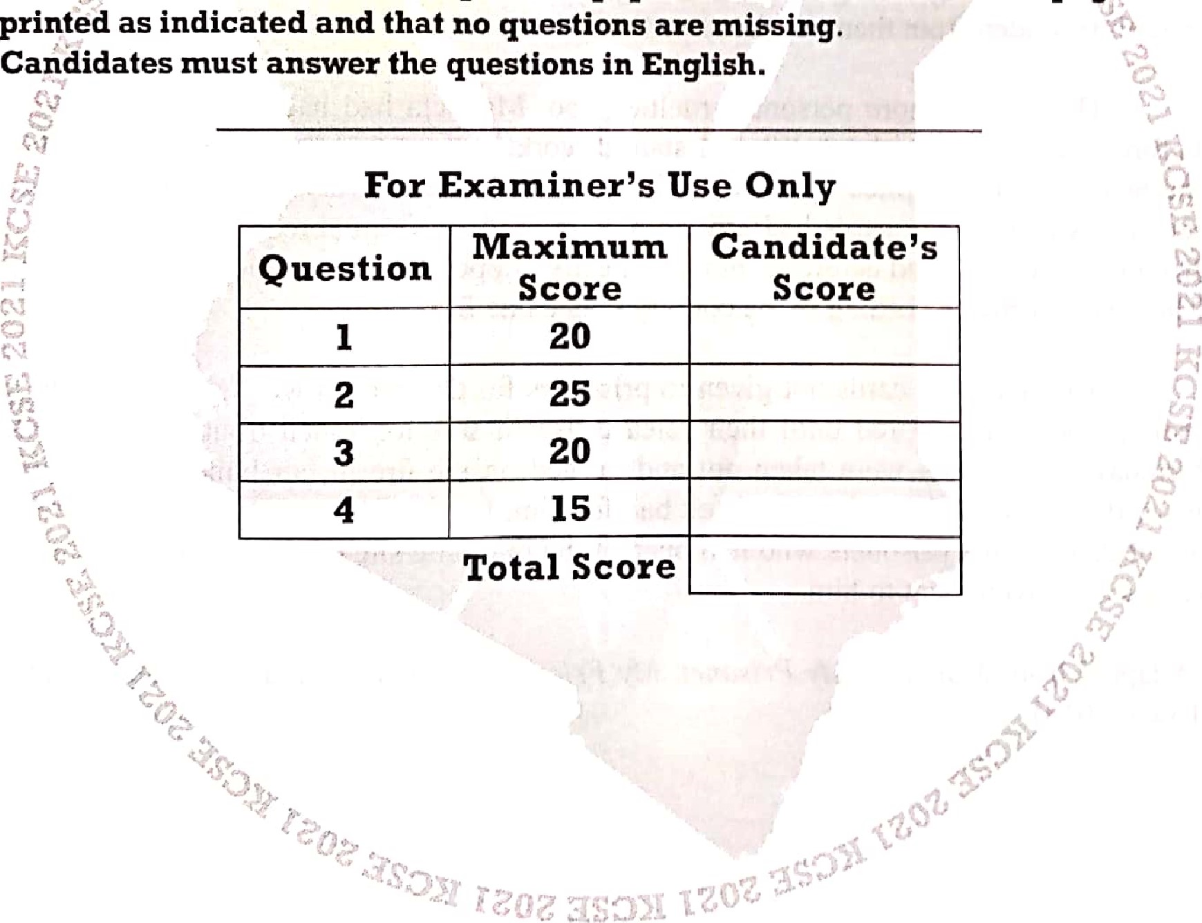
(g)
1 .

0 2021 The Kenya National Examinations Council 101/2
915011 "lin^{e}n over
2
1. Read the passage and then ansll'er the qttestions thatfollow.
Soon after I started work on Robben Island, I was told I'd be filling in for someone on night shift in the censor's office. I had to start at 4 p.m. and wouldn't finish until 7 the next morning. We were on alert all night in case Of emergencies, such as an attempted break-out or a medical crisis. In addition, the dog-handlers patrolled through every section of the prison on a three-hourly basis,
At night, there were also killer dogs running on chains all the time. The dogs were mostly Rottweilers, really vicious. They would be systematically provoked to make them even madder. They could not be handled; they had to be controlled at the end of long metal poles.
The censor's office was considered the heart of the prison, set right in the centre of the main building, on the second floor, with a view over the whole of B section. But there was no heart in that place. Instead, it was this department that meted out some of the worst cruelty to prisoners, namely the holding back or destruction of their letters, their all-important link to loved ones, and the ruthless censoring of daily news to make them believe their stand against apartheid, was nothing, the sacrifice of their freedom pointless. Instead of the real news, all the prisoners would get to hear about was the boring, uncontroversial stuff such as the deaths of prominent people, government appointments or road traffic accidents, or examples of the government's military successfully taking out ANC strongholds. Any show of solidarity from the outside world would be hidden from them, or destroyed.
There were more personal cruelties, too. Mandela had had his 60th birthday the year before I came to the island. When I started work in the censor's office, I asked what was in the boxes and boxes piled up there, with still more arriving every week. I was told that tens of thousands of birthday cards had arrived for him, mostly from abroad. Each card was removed from its envelope, read carefully and then neatly clipped back on to the outside of the envelope. They were sorted according to the country they came from.
Any letters or cards not given to prisoners for any reason were supposed to be put with their property and stored until their release. But it was too much trouble to keep Mandela's birthday cards. They were taken out and burned on the fire in our boiler-room. Years later, I wanted to tell him about them, as I felt bad for him. But he told me: "Mr. Brand, I already know about that". Some prisoners who had been at the dumping site on the island had found charred scraps and given them to him.
(Adapted from Mandela: My Prisoner, My Friend by Christo Brand with Barbara Jones. Cape
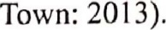
Kenya Certificate ofSecondary Education, 2021 915011
101/2

(a) How did thc authorities ensure that security was tight at the prison on Robben Island?(3 marks)

- Why do you think the security at this prison was tight? (2 marks)

- What does the author have against the way the prisoners were treated at this facility?

(6 marks)

Kenya Certificate ofSecondary Education, 2021
91501 1 101/2
Turn
- In about 65 words, summarise how the way Mandela is treated stands out from how other prisoners are treated. (6 marks)
Rough draft

Fair copy

- Explain the meaning of each of the following as used in the passage: (3 marks)
meted out
  - solidarity
  - charred
Kenya Certificate ofSecondary Education, 2021
915011 101/2

5
2. Henrik Ibsen, A Doll House
Read the excerpt below and then answer the questions thatfollow.

Servant  Nora  Krogstad  Nora  Krogstad  Nora  Krogstad  Nora  Mrs. Linde  Nora  Mrs. Linde Nora  Mrs. Linde  Nora  Mrs. Linde  Nora  Mrs. Linde  Nora  Mrs. Linde  Nora  Doctor Rank  Nora | (at the hall door) Excuse me, ma'am — there is a gentleman to see the master, and as the doctor is with him — Who is it?  (at the door) It is I, Mrs. Helmer. (Mrs. LINDE starts, trembles, and turns to the window.)  (takes a step towards him, and speaks in a strained, low voice) You?  What is it? What do you want to see my husband about?  Bank business — in a way. I have a small post in the Bank, and I hear your husband is to be our chief now — Then it is —  Nothing but dry business matters, Mrs. Helmer; absolutely nothing else.  Be so good as to go into the study then. (She bows indifferently to him and shuts the door into the hall; then comes back and makes up thefire in the stove.)  Nora — who was that man?  A lawyer, of the name of Krogstad.  Then it really was he.  Do you know the man?  T used to — many years ago. At one time he was a solicitor's clerk in our town.  Yes, he was.  He is greatly altered.  He made a very unhappy marriage.  He is a widower now, isn't he?  With several children. There now, it is burning up. (Shuts the door of the stove and moves the rocking-chair aside)  They say he carries on various kinds of business.  Really! Perhaps he does; I don't know anything about it. But don't let us think of business; it is so tiresome.  (comes out ofHELMER {s study. Before he shuts the door he calls to him.) No, my dear fellow, I won't disturb you; I would rather go in to your wife for a little while. (Shuts the door and sees Mrs. Linde.) I beg your pardon; I am afraid I am disturbing you too.  No, not at all. (Introducing him.) Doctor Rank, Mrs. Linde.
Secondmy Education, 2021

Turn
Rank  Mrs. Linde Rank Mrs. Linde Rank  Mrs. Linde Rank Mrs. Linde  Rank Nora  Rank | I have often heard Mrs. Linde's name mentioned here. I think I passed you on the stairs when I arrived, Mrs. Linde?  Yes, I go up very slowly; I can't manage stairs well.  • Ah! some slight internal weakness?  No, the fact is I have been overworking myself.  Nothing more than that? Then I suppose you have come to town to amuse yourself with our entertainments?  I have come to look for work.  Is that a good cure for overwork?  One must live, Doctor Rank,  Yes, the general opinion seems to be that it is necessary.  Look here, Doctor Rank —e you know you want to live.  Certainly. However wretched I may feel, I want to prolong the agony as long as possible. All my patients are like that. And so are those who are morally diseased; one of them, and a bad case too, is at this very moment with Helmer
- Briefly explain what has just happened before this excerpt. (3 marks)

- Nora says, "What do you want to see my husband about?" From your knowledge of the play, why is Nora afraid of Krogstad seeing Helmer? (4 marks)

ofSecondary Education, 2021
915011
- Identity and explain any two instances ol' irony in this excerpt. (4 marks)

- NVith examples, identify any two character traits of Dr. Rank brought out in this excerpt.
(4 marks)

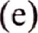Describe the mood in this excerpt. (3 marks)

(f) Identify two characters in this excerpt who can be described as morally diseased and say why. (4 marks)

Secondary Education, 2021
"Iinrn
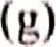Explain the tnctljlijit! Ol' of' IliC j'ollowifjtg


(ii) gt•catly Illtcted

(i i i) dry bugincg,q

Read lhe oral narrative below ///('// ///(' ///t//
Oncc upon a titnc thcrc livcd a Vcty bc;tlllif'ltl in Kirilljli village, Onc day, Karia and I)Cj• wcnt to (lip, ill their which i)) jn that village, thcrc wcrc many ogrcg which could talk and cVCjj %inp, In tJjc cvcjlilj;to iJJC called her daughter who was bathing i') thc t;trcanj, 't Kari;t, ICI Il its and there are many ogres along the way". Karia camc hutTic(lly took J)Ct' which Jjcr J)ad already packed and they wcnt Ijonjc,
On reaching home, Karia noticed that lcft her necklace jn Il)e gardcn, She had rcmovcd it when %hc wag bathing in lhc SJ)C had I)CCJ) p,ivcj) this Jjcckjacc by her grandmother, and shc wag suppo ^{q}cd to t;tkc cajc of' it and it on her first daughter, She was very dcprcsscd whcn shc rcaliscd that %ljc had lcff it lljc She l)Cj' mother whether she could go back for iL I lcr who vcjy of' Ijcr only daughter, refused on grounds that it was already dark and Iijr a young gill to walk through the fi)rest in which thcrc wcrc ogres. Thc mothcr told her, ' 'My (laughtcr, it it} very Jatc now, J)on't you fear the ogres?"
The girl started crying, saying that if'%hc waitcd until daylight, %Jje would find the necklace missing. Jlcr mother went into the kitchen to check wljcthcr the was ready and, on corning out, she found that Karia was not sitting out%idc. Jlcr Ijjolljcr called out, "Karia! Karia! Karia! Whcrc arc you? Come!" She wondcrcd whcrc could havc gone after a tirne. 'J he mother suspected that Karia had (lccidcd to thc neck lacc took Ijnjjjcdiate action, She ran to her brother-in-law's whcrc Ijcr w;i'i, shouting; "father of' Kari;t, cojne with other mcn of the village, Karia has run away and you Should and look her," the way to her brother-in-law's, the mothcr could bc heard jnurrnuring: jny only (laughter is eaten by an ogre, whcrc will I get another onc ()h, my daughter!"
The father, on hearing the news lamented, "What i% wrong with tny daughter'? Couldn't she ask me to buy her another necklace?" About one hour had clapsccl the tijnc the J'ather out with somc village cldcrg to look Kari;t. 'J'hcy wcrc afraid that the ogres jiligl)t eat her up,

oJ'Secondary /'dueat/on, 202/ 91 ,
915011
9
hile, Katia ho had been tmnning, was about to tT(1Ch the garden. She walked slowly for the rtnaining patt ofthe journey for she was now tired, She reached the garden towards the early hours of the motiling. All along the way she was wondering, "If I fail to get the necklace, what will I tell tuy granny?" She quickly went to the place where she had undressed and found that her necklace was still there. She was vets happy and even knelt and bowed facing mount Kirinyaga as a sign of thanks to the gods. She quickly picked up the necklace and then started on her way home, her face beaming, She was very happy that she had not met a single ogre on the way and was thinking of how she would laugh at her tnother who had thought that the ogres would eat her up.
After walking a short distance, she met an ogre which stood in the middle of the road. In order to be allowed to pass, she sang:
Irimu riri, | (You ogre
Tiga kumburia | Do not bother me
Ndi mwana wa Njanwa | I am Njanwa's daughter
Na ke kiuma giki | Take this bead
ureke mbituke. | And let me pass.)
The ogre took the bead and let her pass. The same ogre ran through the bush past her and stopped in the middle of the road again. When she reached the point where it stood, it blocked her She repeated her song. By the time she was halfway back home, she did not have a single bead left, so she said to the ogre, "eat my arm and let me pass". The girl started crying now that she did not even have the necklace which she had gone for and still she had to give the ogre something in order to be allowed to pass.
The ogre kept demanding for more parts of the girl's body. After a while, she had only one leg left and so the ogre decided to eat her up. At this point, her father and the village elders appeared but it was too late. The angry parents decided to kill the ogre. Despite this, they couldn't recover their daughter. In the end, the daughter had lost the bead-necklace and her life to the ogre. The father and the village elders went back home miserable without talking to one another. The father was seriously thinking of how his wife would receive the news.
Thus ends the story.
From: Narratives from Africa and Indiafor Secondary Schools and Colleges by Elegwa Slukulu and Muriuki Wakarangau. Nairobi: Jomo Kenyatta Foundation.
- What kind of narrative is this? Explain your answer. (2 marks)

- Why was Karia worried about losing the necklace? (l mark)

Secondary Education, 2021 lirrn
10
- Identify and illustrate three character traits of Karia's mother. (6 marks)

What is the role of Karia's grandmother in the narrative? | (2 marks)
Identify mo instances of irony in the oral narrative? | (4 marks)
(d)
(e)

(f) Identify and illustrate three things we learn about the culture of the community from which this narrative is drawn.
(3 marks)

ofSecondary Education, 2021
915011

 ト、い山0いs:取ヾい「山いヾいい、 いⅢ Ⅲい)

い) Rい、ⅵに。、ズ,〃(川、わべ、、。、0、℃、ヾ、れ、(、( ,ハか塒れ) 0、ⅲ ⅵに広リバハ、0、〃卩広ソ、0第( , / 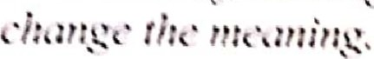 いⅢⅢい)
MVいⅨ、トにis、い町ⅲいde、、gin:

It is nいいぐsドⅢ) to Ⅲいe 3トいut ⅱ、( Bぐじⅲ :、いいneed

 |  | J Ⅲ10 hasトeenヨでいⅢロいe Ⅲ・、、いⅢズ、Ⅲ・、

(ト) Fillー″じわれ川んソなれ℃、、いゾthe' c(リれ℃/ /、盟(ゾ″れ, Ⅳ(叭な海ん・(れ(・な、 
(Pt'OtlOllttee) did nいい川爪e 8じいじいtheいいにいee.
、
(ii) The (collide)国、山じtwo 10 Ⅳ沁トeいtild have been avoided日 the 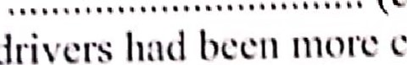
( ⅲ) God'S岱(eいいⅢで).
(e)
(yいい、you {ltld Ⅲじ)
(ii) Jane、as well as(yotl匚)いいbeen shortlisted.
( ⅲ ) Between(you litid匚you Ⅲ tue)山ⅲ 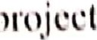 is川いdい
Cail.
50 Ⅱ Ⅷ 1/2 
12
- Complete the second sentence in each case without changing the meaning offhefirst one. (3 marks)
  - There is something suspicious about that deal. I smell (ii) My neighbour plays very loud music late at night. He really gets on

(iii) You should have more confidence in yourself. Do not sell

- Fill in the blanks with the correct preposition. (3 marks)
  - The teacher congratulated him his good performance in English.
  - They disagreed who should be chosen the leader.
  - Mwenda dipped the bucket the well.
THIS IS THE LAST PRINTED PAGE.
Kenya Certificate ofSecondary Education, 2021
915011 101/2

